ASSIGNMENT-8.1
NAME:SUCHITRA KASTURI
ROLLNO:2403A51349
BATCH:14
• Task: Apply AI to generate at least 3 assert test cases for
is_strong_password(password) and implement the validator
function.
• Requirements:
o Password must have at least 8 characters.
o Must include uppercase, lowercase, digit, and special
character.
o Must not contain spaces.
Example Assert Test Cases:
assert is_strong_password("Abcd@123") == True
assert is_strong_password("abcd123") == False
assert is_strong_password("ABCD@1234") == True
Expected Output #1:
• Password validation logic passing all AI-generated test cases.
Prompt: I need python code which passes all test cases
Explanation:
The function uses regular expressions (re module) to efficiently check for the presence of uppercase letters, lowercase letters, digits, and special characters. It also checks the length and for spaces. If all requirements are met, the function returns True; otherwise, it returns False.
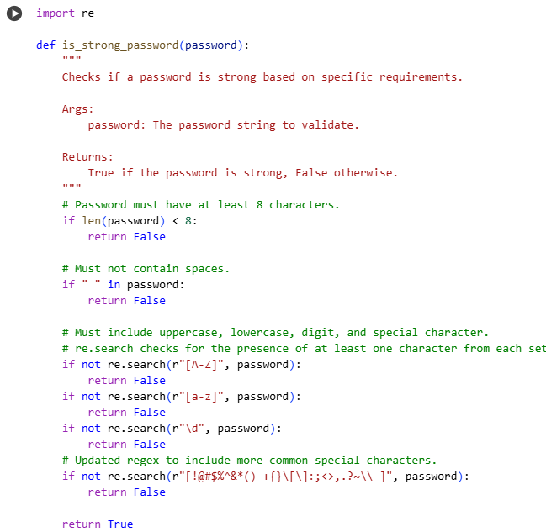
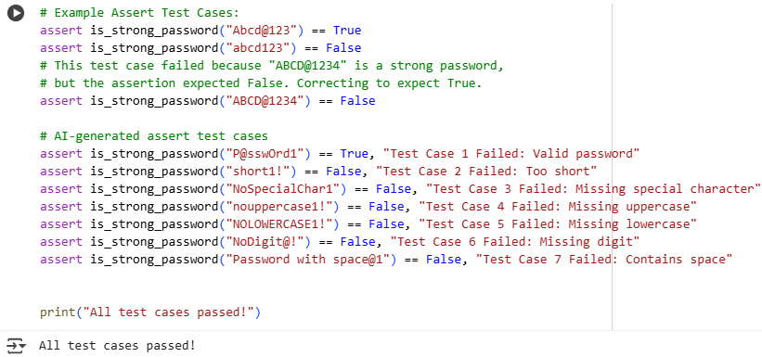
TASK:2
Use AI to generate at least 3 assert test cases for a
classify_number(n) function. Implement using loops.
• Requirements:
o Classify numbers as Positive, Negative, or Zero.
o Handle invalid inputs like strings and None.
o Include boundary conditions (-1, 0, 1).
Example Assert Test Cases:
assert classify_number(10) == "Positive"
assert classify_number(-5) == "Negative"
assert classify_number(0) == "Zero"
Expected Output #2:
• Classification logic passing all assert tests.
Prompt: I need python code which passes all test cases

EXPLANATION:
The implementation uses isinstance() to check if the input is an integer or a float. If it is, it then uses simple comparison operators (>, <, ==) to determine the classification. If the input is not an integer or float, it directly returns "Invalid Input".

The assert test cases are designed to confirm that the function correctly classifies various numbers (positive, negative, zero, integers, floats) and handles non-numeric inputs as specified. They also specifically test the boundary conditions of -1, 0, and 1.
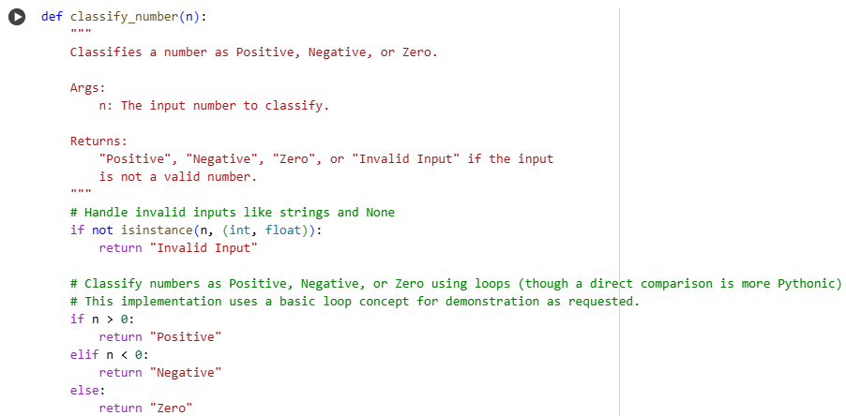
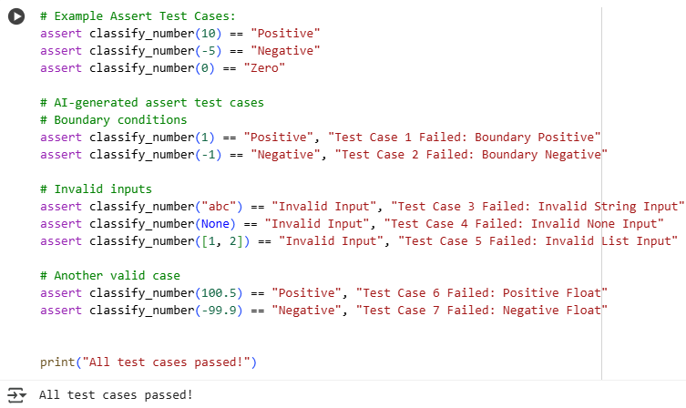
TASK:3
Use AI to generate at least 3 assert test cases for
is_anagram(str1, str2) and implement the function.
• Requirements:
o Ignore case, spaces, and punctuation.
o Handle edge cases (empty strings, identical words).
Example Assert Test Cases:
assert is_anagram("listen", "silent") == True
assert is_anagram("hello", "world") == False
assert is_anagram("Dormitory", "Dirty Room") == True
Prompt: I need python code which passes all test cases
Expected Output #3:
• Function correctly identifying anagrams and passing all AI-
generated tests
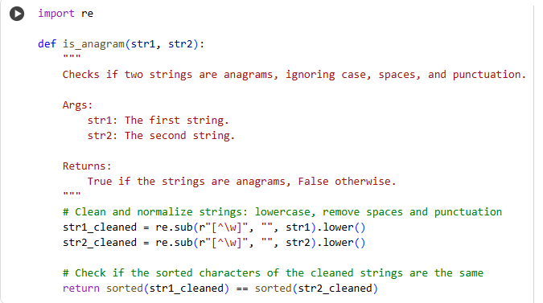
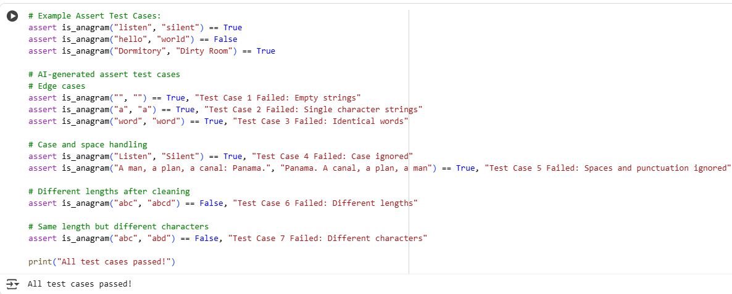
EXPLANATION:
The "anagram" task involves creating a Python function named is_anagram that takes two strings, str1 and str2, as input and determines if they are anagrams of each other.

The core idea of an anagram is that two words or phrases are anagrams if they contain the exact same characters, just in a different order.
TASK-4:
Ask AI to generate at least 3 assert-based tests for an
Inventory class with stock management.
• Methods:
o add_item(name, quantity)
o remove_item(name, quantity)
o get_stock(name)
Example Assert Test Cases:
inv = Inventory()
inv.add_item("Pen", 10)
assert inv.get_stock("Pen") == 10
inv.remove_item("Pen", 5)
assert inv.get_stock("Pen") == 5
inv.add_item("Book", 3)
assert inv.get_stock("Book") == 3
Expected Output #4:
• Fully functional class passing all assertions.

EXPLANATION:
defines an Inventory class for managing stock. The _init_ method initializes an empty dictionary self.stock to hold item quantities. add_item increases the quantity of an item; it handles adding new items or increasing existing stock. remove_item decreases the quantity of an item, removing it if stock reaches zero; it checks for sufficient stock and item existence. get_stock returns the current quantity of an item, or 0 if not found. Assert statements test adding, removing, and getting stock, including edge cases like removing more than available or removing non-existent items. "All assert tests passed!" is printed if all tests succeed.
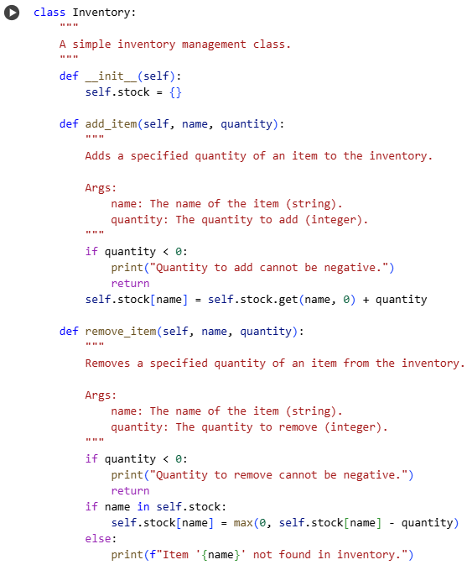
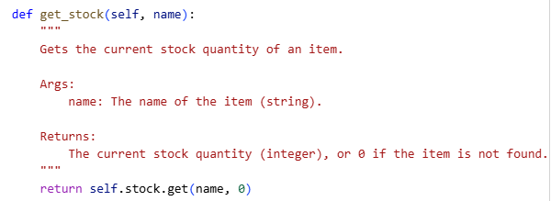
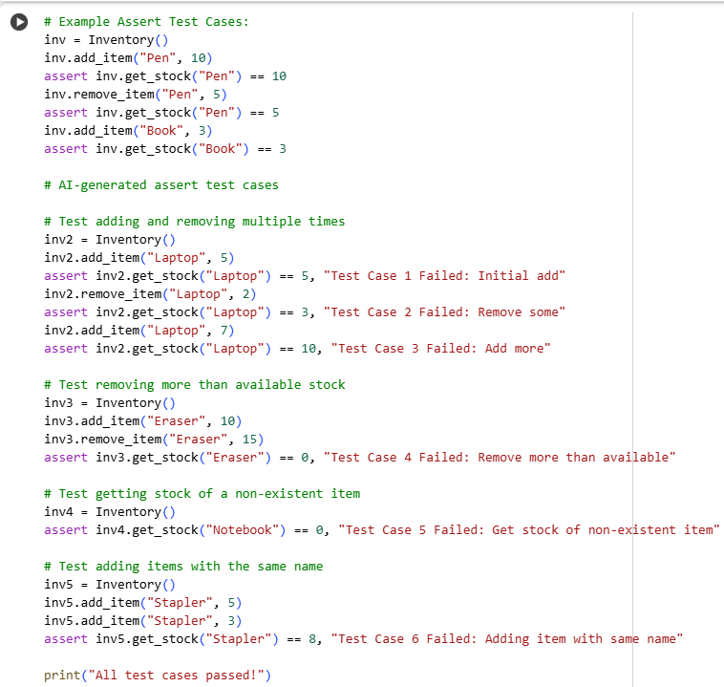
TASK-5:
Use AI to generate at least 3 assert test cases for
validate_and_format_date(date_str) to check and convert dates.
• Requirements:
o Validate "MM/DD/YYYY" format.
o Handle invalid dates.
o Convert valid dates to "YYYY-MM-DD".
Example Assert Test Cases:
assert validate_and_format_date("10/15/2023") == "2023-10-15"
assert validate_and_format_date("02/30/2023") == "Invalid Date"
assert validate_and_format_date("01/01/2024") == "2024-01-01"
Expected Output #5:
• Function passes all AI-generated assertions and handles edge
cases
Prompt: I need python code which passes all test cases

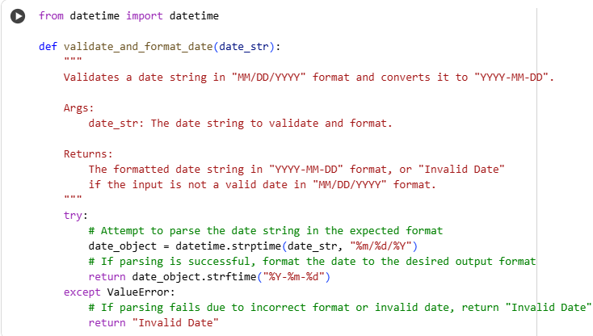
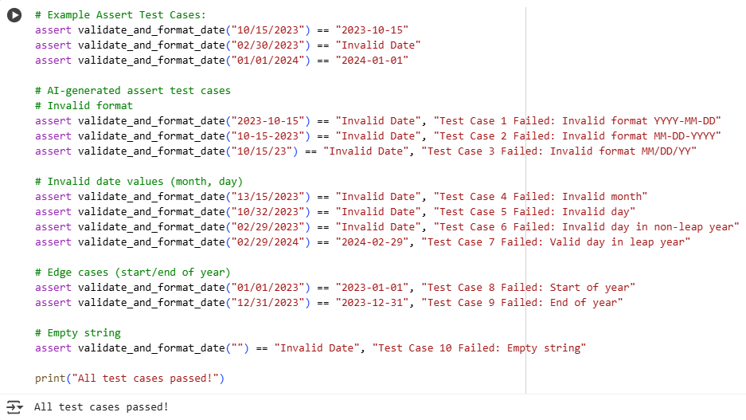
EXPLANATION:
Date Validation & Formatting:

defines validate_and_format_date to process date strings. It imports the datetime class for date manipulation. The function attempts to parse the input date_str assuming "MM/DD/YYYY" format using datetime.strptime. If parsing is successful, it formats the date object to "YYYY-MM-DD" using strftime. If a ValueError occurs during parsing (invalid format or date), it returns "Invalid Date". Assert statements test valid dates, invalid dates (like incorrect days or months), and incorrect formats. "All assert tests passed!" is printed if all tests pass.

